Palm Sunday

Sunday of the Passion
March 24, 2024
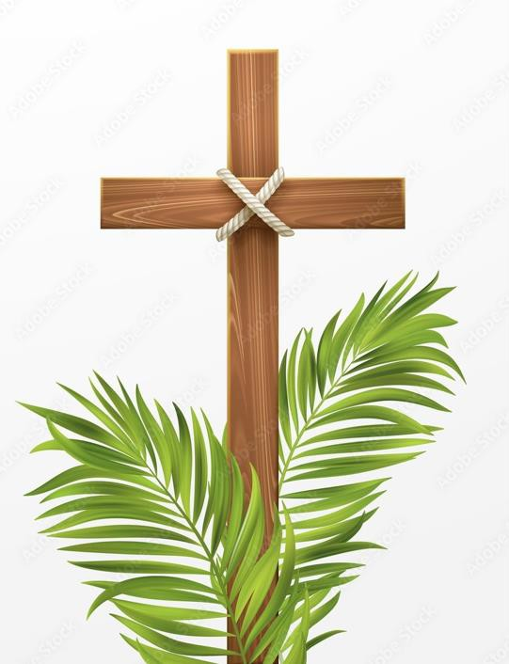

200 Duhring Street, Bluefield, WV 24701
(304) 327-6861 www.cecblf.org

Prelude

The congregation will gather in the narthex for the blessing of the palms

The Liturgy of the Palms

The people standing.

Celebrant Blessed is the King who comes in the name of the Lord.
People Peace in heaven and glory in the highest.

Celebrant Let us pray.
Assist us mercifully with your help, O Lord God of our salvation, that we may enter with joy upon the contemplation of those mighty acts, whereby you have given us life and immortality; through Jesus Christ our Lord. Amen.

Reading from the Gospel of Mark Mark 11:1-11
When they were approaching Jerusalem, at Bethphage and Bethany, near the Mount of Olives, Jesus sent two of his disciples and said to them, “Go into the village ahead of you, and immediately as you enter it, you will find tied there a colt that has never been ridden; untie it and bring it. If anyone says to you, ‘Why are you doing this?’ just say this, ‘The Lord needs it and will send it back here immediately.’” They went away and found a colt tied near a door, outside in the street. As they were untying it, some of the bystanders said to them, “What are you doing, untying the colt?” They told them what Jesus had said; and they allowed them to take it. Then they brought the colt to Jesus and threw their cloaks on it; and he sat on it. Many people spread their cloaks on the road, and others spread leafy branches that they had cut in the fields. Then those who went ahead and those who followed were shouting,

“Hosanna!
Blessed is the one who comes in the name of the Lord!
Blessed is the coming kingdom of our ancestor David!
Hosanna in the highest heaven!”

Then he entered Jerusalem and went into the temple; and when he had looked around at everything, as it was already late, he went out to Bethany with the twelve.

Celebrant The Lord be with you.
People And also with you.
Celebrant Let us give thanks to the Lord our God.
People It is right to give him thanks and praise.

Celebrant
It is right to praise you, Almighty God, for the acts of love by which you have redeemed us through your Son Jesus Christ our Lord. On this day he entered the holy city of Jerusalem in triumph, and was proclaimed as King of kings by those who spread their garments and branches of palm along his way. Let these branches be for us signs of his victory, and grant that we who bear them in his name may ever hail him as our King, and follow him in the way that leads to eternal life; who lives and reigns in glory with you and the Holy Spirit, now and for ever. Amen.

At this time the blessed Palms will be distributed to the congregation.

Celebrant Blessed is he who comes in the name of the Lord.
People Hosanna in the highest.

The people process in first, holding branches in their hands, followed by the choir and Celebrant while the hymn is played.

Hymn All glory, laud, and honor H 154

At this time, all children are invited to follow the cross and teachers to their classrooms.

The Collect

Almighty God, whose most dear son went not up to joy but first he suffered pain, and entered not into glory before he was crucified: Mercifully grant that we, walking in the way of the cross, may find it none other than the way of life and peace; through Jesus Christ our Lord. AMEN.

The Liturgy of the Word

Let us pray.

Almighty and everliving God, in your tender love for the human race you sent your Son our Savior Jesus Christ to take upon him our nature, and to suffer death upon the cross, giving us the example of his great humility: Mercifully grant that we may walk in the way of his suffering, and also share in his resurrection; through Jesus Christ our Lord, who lives and reigns with you and the Holy Spirit, one God, for ever and ever. Amen.

Old Testament Lesson Isaiah 50:4-9a
The Lord God has given me the tongue of a teacher, that I may know how to sustain the weary with a word. Morning by morning he wakens-- wakens my ear to listen as those who are taught. The Lord God has opened my ear, and I was not rebellious, I did not turn backward. I gave my back to those who struck me, and my cheeks to those who pulled out the beard; I did not hide my face from insult and spitting.
The Lord God helps me; therefore I have not been disgraced;
therefore I have set my face like flint, and I know that I shall not be put to shame; he who vindicates me is near. Who will contend with me? Let us stand up together. Who are my adversaries? Let them confront me. It is the Lord God who helps me; who will declare me guilty?
Lector The Word of the Lord.
People Thanks be to God!

The Psalm Psalm 31:9-16 In te, Domine, speravi
- Have mercy on me, O LORD, for I am in trouble; my eye is consumed with sorrow, and also my throat and my belly.
- For my life is wasted with grief, and my years with sighing; my strength fails me because of affliction, and my bones are consumed.
- I have become a reproach to all my enemies and even to my neighbors, a dismay to those of my acquaintance; when they see me in the street they avoid me.
- I am forgotten like a dead man, out of mind; I am as useless as a broken pot.
- For I have heard the whispering of the crowd; fear is all around; they put their heads together against me; they plot to take my life.
- But as for me, I have trusted in you, O LORD. I have said, "You are my God.
- My times are in your hand; rescue me from the hand of my enemies, and from those who persecute me.
- Make your face to shine upon your servant, and in your loving-kindness save me."

New Testament Lesson Philippians 2:5-11
Let the same mind be in you that was in Christ Jesus, who, though he was in the form of God, did not regard equality with God as something to be exploited, but emptied himself, taking the form of a slave, being born in human likeness. And being found in human form, he humbled himself and became obedient to the point of death-- even death on a cross. Therefore, God also highly exalted him and gave him the name that is above every name, so that at the name of Jesus every knee should bend, in heaven and on earth and under the earth, and every tongue should confess that Jesus Christ is Lord, to the glory of God the Father.
Lector The Word of the Lord.
People Thanks be to God!

Hymn Glory be to Jesus, who in bitter pain H 479

The congregation may be seated for the first part of the Passion.

The Passion of our Lord Jesus Chris according to Mark Mark 15:1-39
As soon as it was morning, the chief priests held a consultation with the elders and scribes and the whole council. They bound Jesus, led him away, and handed him over to Pilate. Pilate asked him, “Are you the King of the Jews?” He answered him, “You say so.” Then the chief priests accused him of many things. Pilate asked him again, “Have you no answer? See how many charges they bring against you.” But Jesus made no further reply, so that Pilate was amazed.
Now at the festival he used to release a prisoner for them, anyone for whom they asked. Now a man called Barabbas was in prison with the rebels who had committed murder during the insurrection. So the crowd came and began to ask Pilate to do for them according to his custom. Then he answered them, “Do you want me to release for you the King of the Jews?” For he realized that it was out of jealousy that the chief priests had handed him over. But the chief priests stirred up the crowd to have him release Barabbas for them instead. Pilate spoke to them again, “Then what do you wish me to do with the man you call the King of the Jews?” They shouted back, “Crucify him!” Pilate asked them, “Why, what evil has he done?” But they shouted all the more, “Crucify him!” So Pilate, wishing to satisfy the crowd, released Barabbas for them; and after flogging Jesus, he handed him over to be crucified.
Then the soldiers led him into the courtyard of the palace (that is, the governor’s headquarters); and they called together the whole cohort. And they clothed him in a purple cloak; and after twisting some thorns into a crown, they put it on him. And they began saluting him, “Hail, King of the Jews!” They struck his head with a reed, spat upon him, and knelt down in homage to him. After mocking him, they stripped him of the purple cloak and put his own clothes on him. Then they led him out to crucify him.
They compelled a passer-by, who was coming in from the country, to carry his cross; it was Simon of Cyrene, the father of Alexander and Rufus.

All Stand
Then they brought Jesus to the place called Golgotha (which means the place of a skull). And they offered him wine mixed with myrrh; but he did not take it. And they crucified him, and divided his clothes among them, casting lots to decide what each should take.
It was nine o’clock in the morning when they crucified him. The inscription of the charge against him read, “The King of the Jews.” And with him they crucified two bandits, one on his right and one on his left. Those who passed by derided him, shaking their heads and saying, “Aha! You who would destroy the temple and build it in three days, save yourself, and come down from the cross!” In the same way the chief priests, along with the scribes, were also mocking him among themselves and saying, “He saved others; he cannot save himself. Let the Messiah, the King of Israel, come down from the cross now, so that we may see and believe.” Those who were crucified with him also taunted him.
When it was noon, darkness came over the whole land until three in the afternoon. At three o’clock Jesus cried out with a loud voice, “Eloi, Eloi, lema sabachthani?” which means, “My God, my God, why have you forsaken me?” When some of the bystanders heard it, they said, “Listen, he is calling for Elijah.” And someone ran, filled a sponge with sour wine, put it on a stick, and gave it to him to drink, saying, “Wait, let us see whether Elijah will come to take him down.” Then Jesus gave a loud cry and breathed his last. And the curtain of the temple was torn in two, from top to bottom. Now when the centurion, who stood facing him, saw that in this way he breathed his last, he said, “Truly this man was God’s Son!”

The Sermon The Rev. Paul Barker

The Prayers of the People, Form IV
Let us pray for the Church and for the world.
Grant, Almighty God, that all who confess your Name may be united in your truth, live together in your love, and reveal your glory in the world.

Silence

Lord, in your mercy
Hear our prayer.

Guide the people of this land, and of all the nations, especially at this time, in the ways of justice and peace; that we may honor one another and serve the common good.

Silence

Lord, in your mercy
Hear our prayer.
Give us all a reverence for the earth as your own creation, that we may use its resources rightly in the service of others and to your honor and glory.

Silence

Lord, in your mercy
Hear our prayer.
Bless all whose lives are closely linked with ours, and grant that we may serve Christ in them, and love one another as Christ loves us.

Silence

Lord, in your mercy
Hear our prayer.
We pray for all who are ill, or in any trouble, need or sorrow, especially those on our parish prayer list, and for any others we might now name, either silently or aloud. (Pause) Comfort and heal all those who suffer in body, mind, or spirit; give them courage and hope in their troubles and bring them the joy of your salvation.

Silence

Lord, in your mercy
Hear our prayer.
We pray for all who have died, especially our loved ones who have gone before us, and for any others we might now name, either silently or aloud. (Pause) We commend to your mercy all who have died, that your will for them may be fulfilled; and we pray that we may share with all your saints in your eternal kingdom.

Silence

Lord, in your mercy
Hear our prayer.

In our Diocesan Cycle of Prayer, we pray for all Christians who face persecution.
Silence

Lord, in your mercy
Hear our prayer.

Celebrant
Heavenly Father, you have promised to hear what we ask in the Name of your Son: Accept and fulfill our petitions, we pray, not as we ask in our ignorance, nor as we deserve in our sinfulness, but as you know and love us in your Son Jesus Christ our Lord. Amen.

The Peace
Celebrant The peace of the Lord be always with you.
People And also with you.

The people may greet one another with a sign of God’s love.

Announcements

The Holy Eucharist
Offertory When I survey the wondrous cross H 474
After the offertory piece has been played, the people stand and sing the familiar tune of the “Old 100”.

Praise God, from whom all blessing flow;
Praise Him, all creatures here below;
Praise Him above, ye heavenly host:
Praise Father, Son, and Holy Ghost.

Eucharistic Prayer A
Celebrant The Lord be with you.
People And also with you.
Celebrant Lift up your hearts.
People We lift them to the Lord.
Celebrant Let us give thanks to the Lord our God.
People It is right to give him thanks and praise.

Then, facing the Holy Table, the Celebrant proceeds
It is right, and a good and joyful thing, always and every- where to give thanks to you, Father Almighty, Creator of heaven and earth. Through Jesus Christ our Lord.
For our sins he was lifted high upon the cross, that he might draw the whole world to himself; and, by his suffering and death, he became the source of eternal salvation for all who put their trust in him.
Therefore we praise you, joining our voices with Angels and Archangels and with all the company of heaven, who for ever say this hymn to proclaim the glory of your Name:
Celebrant and People

The Hymnal 1982, Service Music, #130
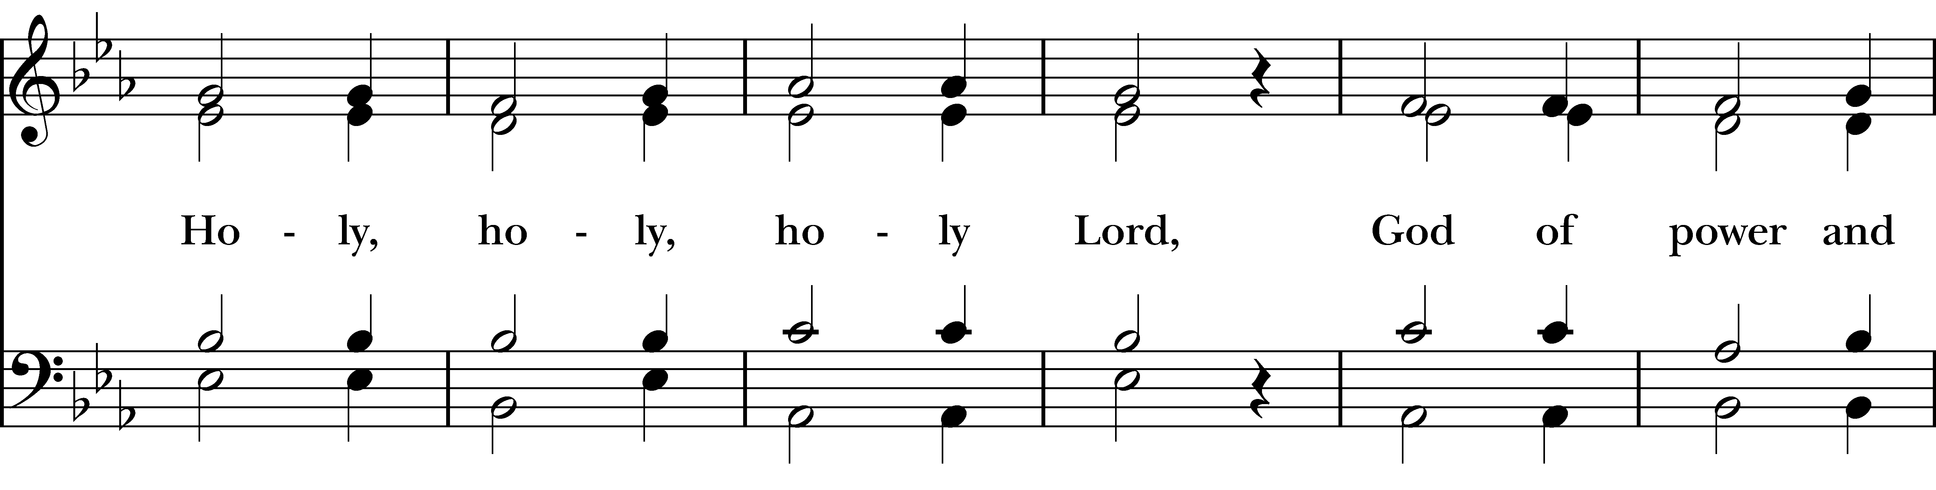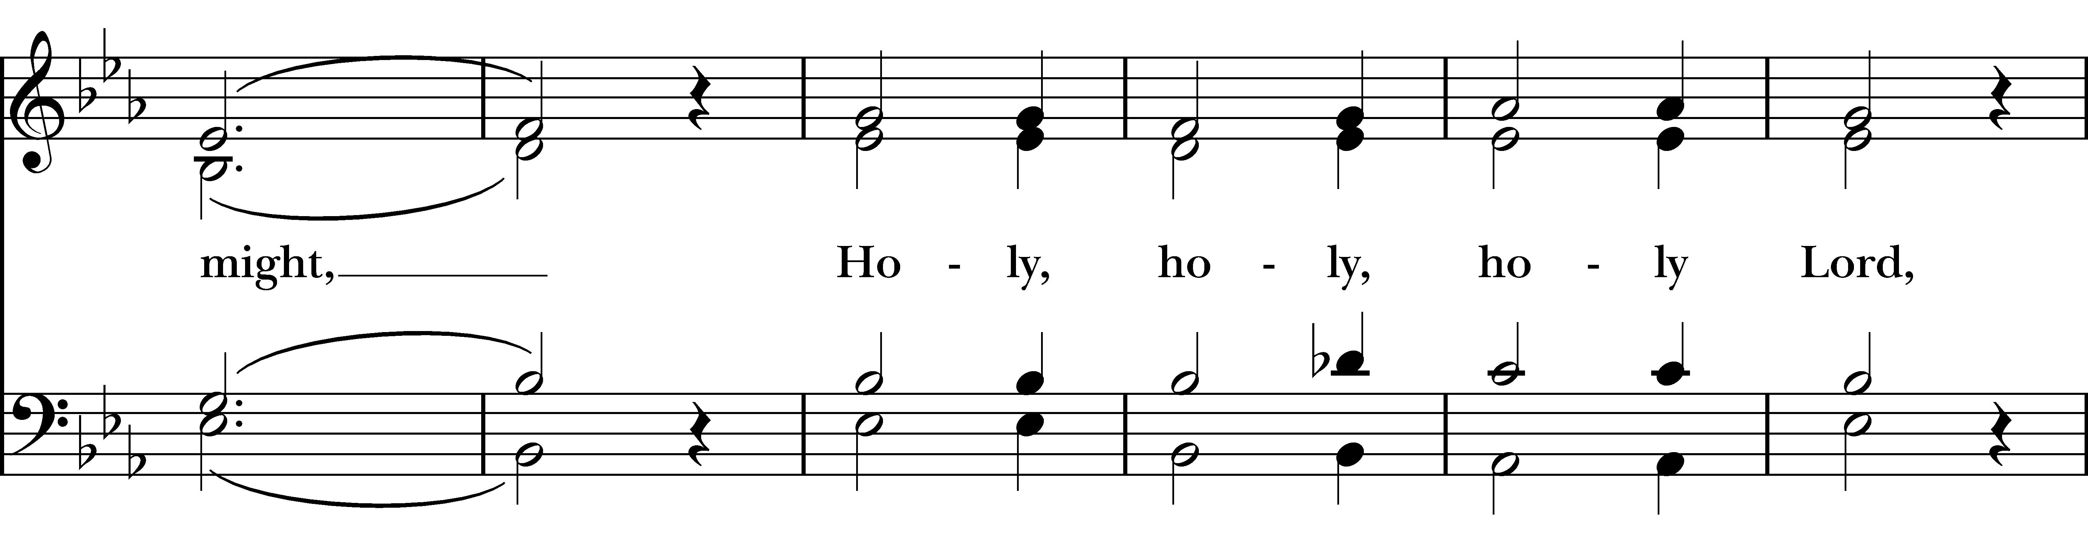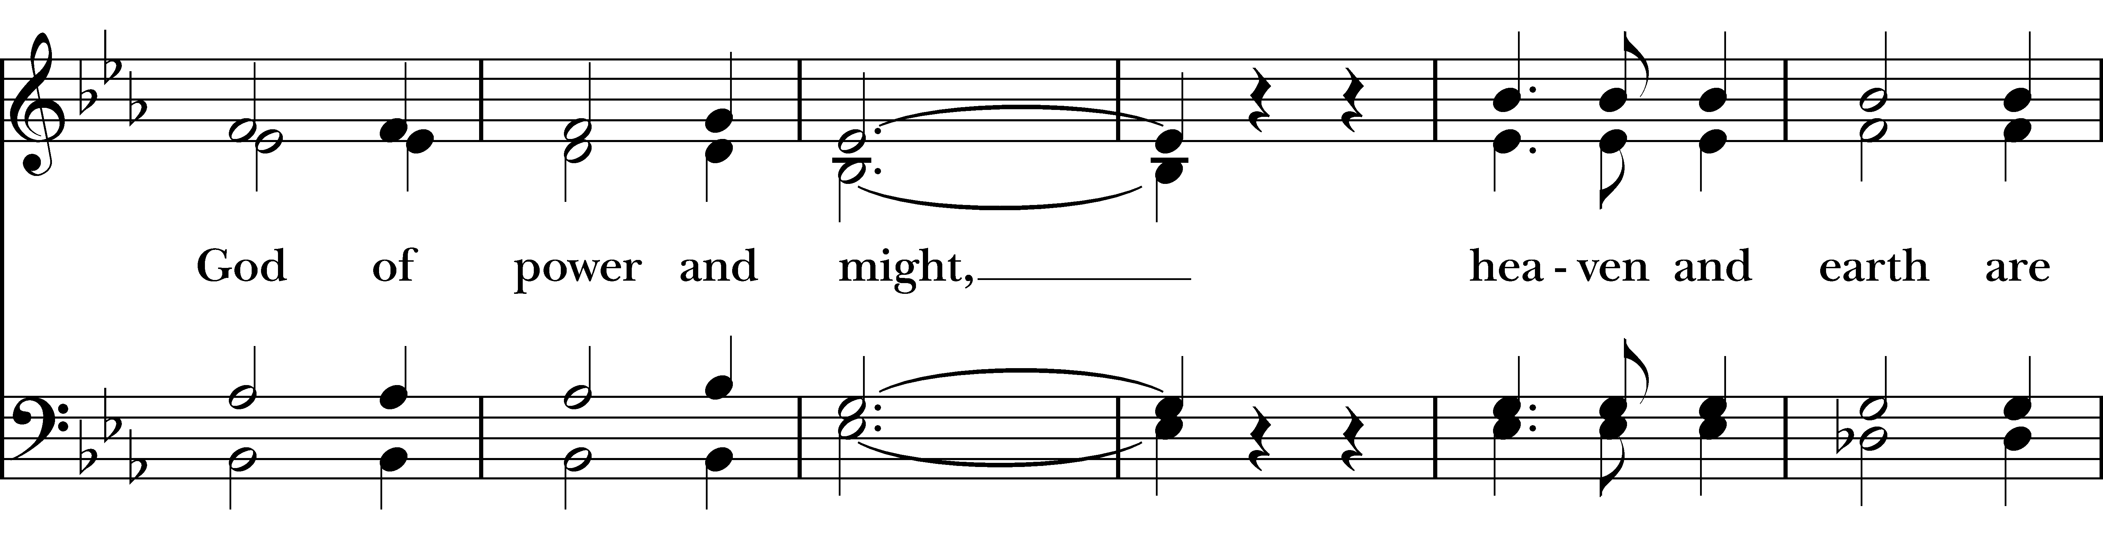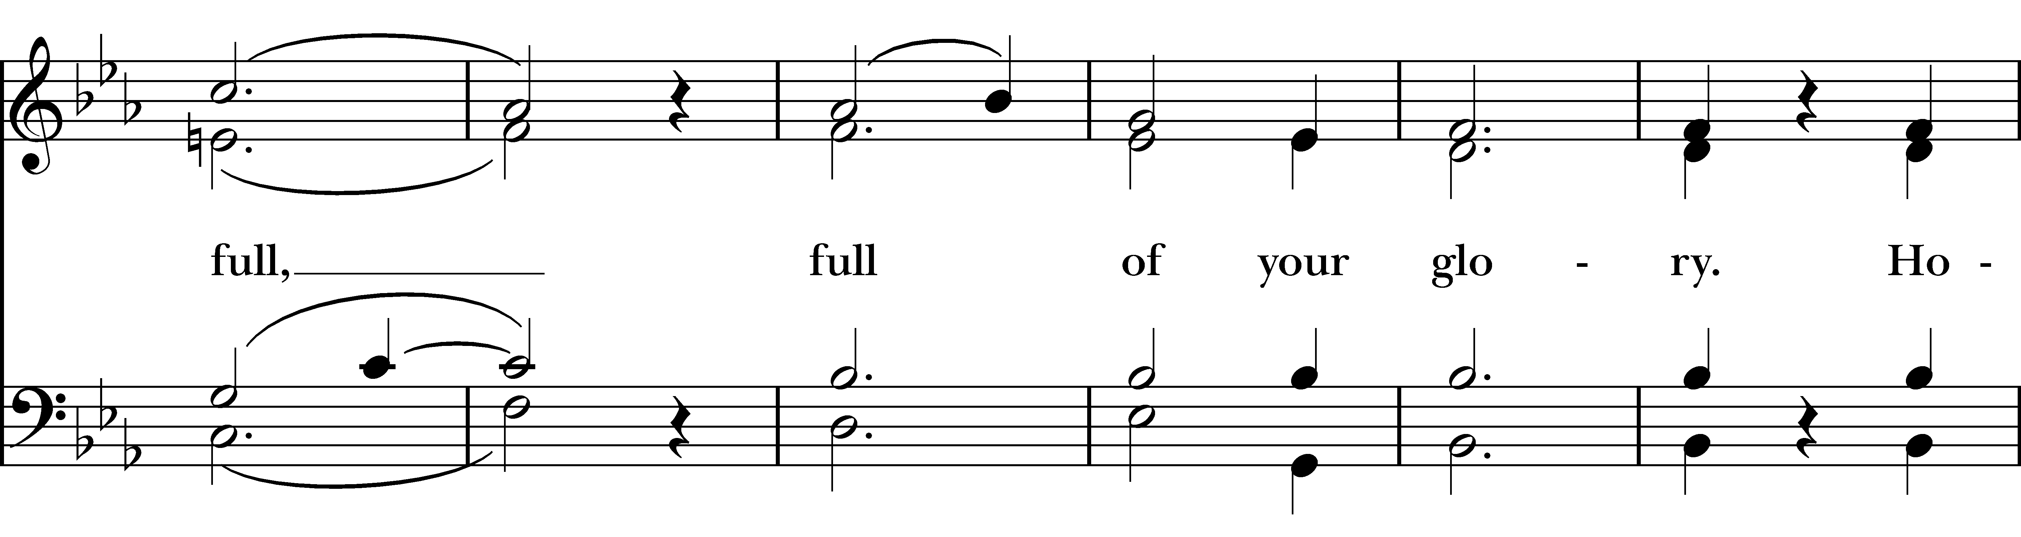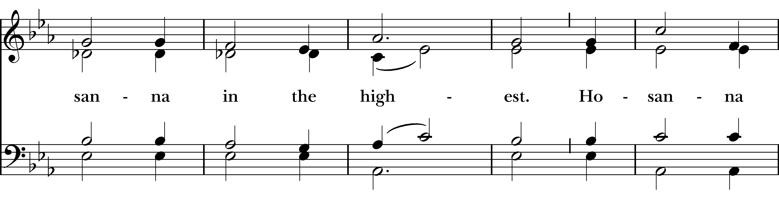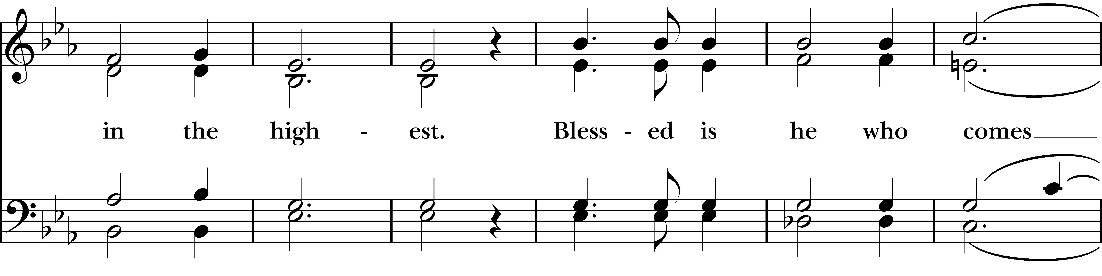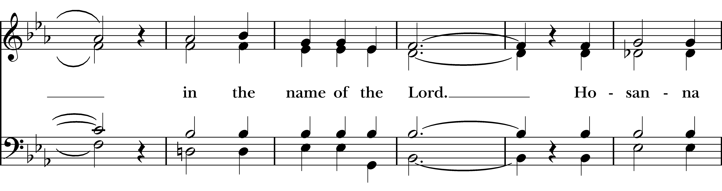
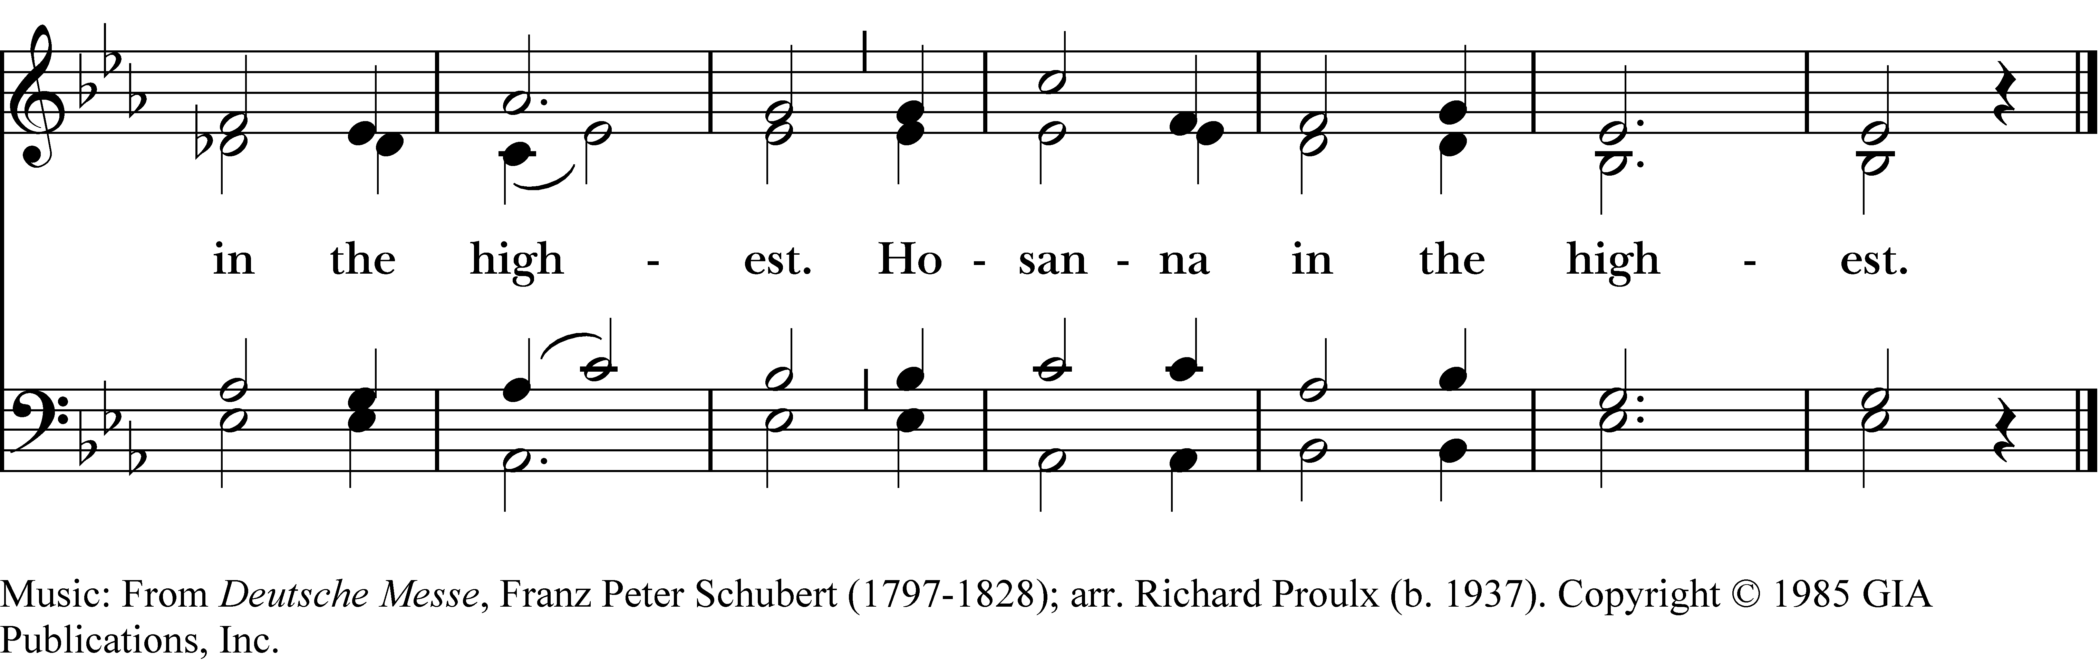
The people stand or kneel.
Then the Celebrant continues

Holy and gracious Father: In your infinite love you made us for yourself, and, when we had fallen into sin and become subject to evil and death, you, in your mercy, sent Jesus Christ, your only and eternal Son, to share our human nature, to live and die as one of us, to reconcile us to you, the God and Father of all.

He stretched out his arms upon the cross, and offered himself, in obedience to your will, a perfect sacrifice for the whole world.

On the night he was handed over to suffering and death, our Lord Jesus Christ took bread; and when he had given thanks to you, he broke it, and gave it to his disciples, and said, "Take, eat: This is my Body, which is given for you. Do this for the remembrance of me."

After supper he took the cup of wine; and when he had given thanks, he gave it to them, and said, "Drink this, all of you: This is my Blood of the new Covenant, which is shed for you and for many for the forgiveness of sins. Whenever you drink it, do this for the remembrance of me."

Therefore we proclaim the mystery of faith:

Celebrant and People
Christ has died.
Christ is risen.
Christ will come again.

The Celebrant continues
We celebrate the memorial of our redemption, O Father, in this sacrifice of praise and thanksgiving. Recalling his death, resurrection, and ascension, we offer you these gifts.

Sanctify them by your Holy Spirit to be for your people the Body and Blood of your Son, the holy food and drink of new and unending life in him.

Sanctify us also that we may faithfully receive this holy Sacrament, and serve you in unity, constancy, and peace; and at the last day bring us with all your saints into the joy of your eternal kingdom.

All this we ask through your Son Jesus Christ: By him, and with him, and in him, in the unity of the Holy Spirit all honor and glory is yours, Almighty Father, now and for ever. AMEN.

Celebrant And now as our Savior Christ has taught us, we are bold to say:

Celebrant and People together

Our Father, who art in heaven, hallowed be thy Name,
Thy kingdom come, thy will be done,
on earth as it is in heaven. Give us this day our daily bread. And forgive us our trespasses,
as we forgive those
who trespass against us.
And lead us not into temptation, but deliver us from evil.
For thine is the kingdom,
and the power, and the glory, for ever and ever. Amen.

The Celebrant then presents the Sacrament to the people.

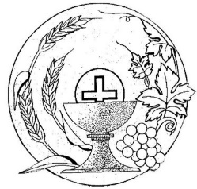
The Breaking of the Bread
The Celebrant then breaks the Consecrated Bread and says
Christ our Passover is sacrificed for us;

People Therefore let us keep the feast.

The Celebrant then presents the Sacrament to the People
The Gifts of God, for the People of God. Take them in remembrance that Christ died for you, and feed on him in your hearts by faith, with thanksgiving.

The Distribution of the Holy Sacrament
All baptized Christians, regardless of age or denomination, are invited and encouraged to receive the sacrament. Communion is distributed at the altar rail. It is the tradition of this parish that 12 to 14 people at a time receive communion at the altar rail, at which point all are dismissed together to return to their seats and another group may move forward to the rail. Gluten free wafers are available by asking the priest. If you do not wish to receive the sacrament but would like to receive a blessing, please join us at the rail and cross your arms over your chest. Depart through the doors at either side of the rail, returning to your pew through the door by the reader’s lectern.

The Prayer for Spiritual Communion
In union, O Lord, with your faithful people at every altar of your Church, where the Holy Eucharist is now being celebrated, I desire to offer to you
praise and thanksgiving. I remember your death, Lord Christ; I proclaim your resurrection; I await your coming in glory. And since I cannot receive you today in the Sacrament of your Body and Blood, I beseech you to come spiritually into my heart. Cleanse and strengthen me with your grace, Lord Jesus, and let me never be separated from you. May I live in you, and you in me, in this life and in the life to come. Amen.

Communion Hymns
Let thy Blood in mercy poured H 313
O sacred head, sore wounded H 168

Our Prayer after Communion
Celebrant Let us pray.

Celebrant and People

Almighty and everliving God,
we thank you for feeding us with the spiritual food of the most precious Body and Blood
of your Son our Savior Jesus Christ;
and for assuring us in these holy mysteries
that we are living members of the Body of your Son, and heirs of your eternal kingdom.
And now, Father, send us out
to do the work you have given us to do,
to love and serve you
as faithful witnesses of Christ our Lord. To him, to you, and to the Holy Spirit,
be honor and glory, now and for ever. Amen.

Recessional At the Name of Jesus H 435

The Dismissal
The departing minister then says
Let us go forth in the name of Christ.
People Thanks be to God.

Postlude

Birthdays this week: Liam Cole, Elizabeth Suddeth

The palms are given by Mike and Sloane Hunter in loving memory of
Mrs. Betsy Davis and Mrs. Ann Hillier.

Please Keep the Following in Your Prayers: Dorene Dimes, Bonnie Taylor, Joe Sanders, Bob and Peggy Walk, Martha Linkous, Buck Sowers, Donna Fortune, Ed and Gladys Fortune, Jim and Chris Justice, Ivy and the Gaines Family, Fr. Russ and Debbie Hatfield and family, Mary Lou, Brian, Don Harris, Ted and Katherine Lewis, Jim Dyer, Brian, John and Becky Beckett, Jim Paine, Lane, Sherry, Scot, Max, Brad, Sandi, Joan, Mike Boosier, Pam Spracher, Barry Dinger, Joel Hammond, Martin and Ethan, Jim, Joan Gray, Rosemary, Eddie Hughes, Doug Truter, Jenessa, Ameiah, Beth Kane, Debbie H., Kimberly Norriss, Eric, Mark, and Tim Mainland.

Following our service will be Coffee Hour, hosted by Vestry members. This is a time for us to have fellowship, share our joys and sorrows, and get to know one another better. It is very much an extension of the communal feast we share in the Holy Eucharist. Please join us!

Participants in Today’s Liturgy

Celebrant The Rev. Paul Barker
Organist & Choirmaster Terry E. Whittington, Jr.
Acolyte Katherine Lewis
Lector Rob Merritt
Altar Guild Elizabeth Clement, Betty Nash, Lisa Van Dyke

Attendance Last Sunday 35

Holy Week Services
Thursday – March 28 Maundy Thursday Service 7:00pm

Friday - March 29 Stations of the Cross at noon

Good Friday Liturgy - Stations 5:30pm

Sunday - March 31 Easter Sunday 10:00am

Calendar of Events
Wednesday – March 27 Union Mission 3:30pm
Holy Week Services
Wednesday – April 3 ECW Dinner at the Church 5:30pm
Saturday – April 6 Vestry Retreat in Rowley Hall 10:00am – 3:00pm
Wednesday – April 10 Union Mission 4:00pm
Sunday – April 14 Guest Preacher, Hannah Anderson
Marriage Blessing after Church
Tuesday – April 16 DOK meeting 10:30am
Wednesday – April 17 Men’s Dinner 6:00pm
Vestry meeting 7:00pm
Thursday – April 18 Food Pantry 9:00am – 11:00am
Sunday – April 21 Carry-in luncheon after Church
Wednesday – April 24 Union Mission 3:30pm

Announcements:

Directory: If you haven’t returned your completed Questionnaire in yet, please do so. Thank you!

Easter Lilies: A sign-up sheet for those who would like to purchase Easter lilies given in memory or honor of a loved one is available at the Usher’s Table in the Narthex. Lilies will be $20 each. Please sign up by today.

ECW Dinner: The Episcopal Church Women will be having a dinner on April 3 at 5:30pm at the Church.

Coffee Hour: A Coffee Hour host will be needed for April 28. Please sign up on the whiteboard located outside the library. Contact Mary Catherine Williams at: (276-326-2411) or mkw@dlwco.com if you have any questions. Thank you for helping Christ Church in this important ministry.

Clergy, Staff, and Wardens of this Parish
The Rev. Paul Barker Priest
Mr. Terry E. Whittington, Jr. Organist & Choirmaster Ms. Emma Bennett Parish Administrator
Mrs. Vanessa Hall Sexton
Mrs. Becky Beckett Senior Warden
Mr. Peter Richardson Junior Warden

